CS4801 DEVOPS LAB

LAB 7 – END-TO-END CI/CD PIPELINE FOR A JAVA WEB APPLICATION

1. AIM
The purpose of this experiment is to set up a complete CI/CD workflow for a Java web application. Git, Maven, Docker, and Jenkins are combined so that the application can move from source code to a tested and running container through a single automated process.

2. TOOLS AND TECHNOLOGIES USED
Tool / Technology | Version | Purpose in the Project
Java (JDK) | «17» | Programming language and runtime for the application.
Spring Boot | «3.x» | Web framework used to provide the embedded server and REST API endpoints.
Apache Maven | «3.9.x» | Build automation for dependency management, compilation, testing, and packaging.
JUnit 5 | «5.x» | Testing framework whose unit tests are executed automatically during the build.
Git | «2.4x» | Distributed version-control system for application, build, and pipeline files.
GitHub | — | Remote repository that stores the project and is accessed by Jenkins.
Docker Desktop | «4.x» | Provides containerisation for the application artifact and Jenkins controller.
Jenkins | 2.568.3 | Automation server responsible for executing the declarative CI/CD pipeline.
Host OS | «Windows 11» | Development environment, with PowerShell used for terminal operations.

3. PIPELINE ARCHITECTURE
The workflow starts when the project is pushed to the remote Git repository. Jenkins takes over from there and carries out the checkout, Maven build, testing, Docker image creation, deployment, and health check automatically.
Developer → Git Commit & Push → GitHub → Jenkins Checkout → Maven Build & Test
→ Docker Image Build → Container Deployment → Health Verification → Post Actions
Jenkins is itself run as a Docker container in this setup. Its access to the host Docker socket allows the pipeline to create and manage the application container using the host Docker daemon, while Jenkins remains separated from the application environment.

4. IMPLEMENTATION

4.1 Version Control with Git
The project was placed under Git version control and connected to a GitHub repository. Source files, tests, pom.xml, Dockerfile, and Jenkinsfile are included in the repository. Temporary build files and IDE files are ignored through .gitignore, so the project can be rebuilt from a clean checkout.
Repository structure:
student-mgmt/
├── src/
│ ├── main/java/com/example/studentmgmt/
│ │ ├── StudentMgmtApplication.java
│ │ ├── controller/StudentController.java
│ │ ├── model/Student.java
│ │ └── service/StudentService.java
│ └── test/java/com/example/studentmgmt/
│ └── StudentServiceTest.java
├── pom.xml
├── Dockerfile
├── Jenkinsfile
└── .gitignore
Commands used:
git init
git add .
git commit -m "feat: initial Spring Boot skeleton for student management"
git branch -M main
git remote add origin «https://github.com/<username>/student-mgmt».git
git push -u origin main

4.2 Build and Test Automation with Maven
The application uses the usual Maven project structure. The pom.xml contains the dependencies required for the Spring Boot web layer and JUnit testing. The Spring Boot Maven plugin creates an executable JAR with the embedded server, which is later used as the application artifact inside the Docker image.
Key excerpt from pom.xml:
<properties>
<java.version>17</java.version>
</properties>

<dependencies>
<dependency>
<groupId>org.springframework.boot</groupId>
<artifactId>spring-boot-starter-web</artifactId>
</dependency>
<dependency>
<groupId>org.springframework.boot</groupId>
<artifactId>spring-boot-starter-test</artifactId>
<scope>test</scope>
</dependency>
</dependencies>

<build>
<plugins>
<plugin>
<groupId>org.springframework.boot</groupId>
<artifactId>spring-boot-maven-plugin</artifactId>
</plugin>
</plugins>
</build>
Functional operations implemented:
/students | POST | Creates and stores a new student entry in the in-memory data store.
/students | GET | Retrieves all stored student records in JSON format.
/students/health | GET | Provides a simple liveness check used to confirm that the deployment is running.
/students/health | GET | Lightweight liveness probe used by the pipeline to verify deployment.

Unit testing is included in the Maven build itself. The JUnit tests are run during the test phase, and a failed test causes the build to stop. In the recorded run, all three test cases completed successfully.
Build commands:
mvn clean compile # compile the sources
mvn test # execute the JUnit test suite
mvn clean package # run tests and produce target/student-mgmt-0.0.1-SNAPSHOT.jar

4.3 Containerisation with Docker
A two-stage Dockerfile is used for containerisation. Maven is used in the first stage to build the JAR, and the second stage contains only the JRE and the generated application JAR. This separates the build environment from the runtime environment. The final image is about 294 MB, including approximately 86 MB of application content.
Dockerfile:
# ---------- Stage 1: build ----------
FROM maven:3.9-eclipse-temurin-17 AS build
WORKDIR /app
COPY pom.xml .
RUN mvn -B dependency:go-offline
COPY src ./src
RUN mvn -B clean package -DskipTests=false

# ---------- Stage 2: runtime ----------
FROM eclipse-temurin:17-jre
WORKDIR /app
COPY --from=build /app/target/*.jar app.jar
EXPOSE 8080
ENTRYPOINT ["java", "-jar", "app.jar"]
Image build and container run:
docker build -t student-mgmt:latest .
docker run -d --name student-mgmt-app -p 8080:8080 student-mgmt:latest
docker images
docker ps
curl "http://localhost:8080/students/health"
The running container was tested from the host using PowerShell. A request to the health endpoint on port 8080 returned status 200 and the response OK, confirming that the application was available.

4.4 CI/CD Automation with Jenkins
Jenkins LTS was started in a Docker container. Host port 8081 was assigned to Jenkins because port 8080 is used by the application. Port 50000 was exposed for agent communication. The jenkins_home volume stores Jenkins data, and the mounted Docker socket allows the pipeline to work with Docker on the host.
docker run -d --name jenkins -p 8081:8080 -p 50000:50000 \
-v jenkins_home:/var/jenkins_home \
-v /var/run/docker.sock:/var/run/docker.sock \
jenkins/jenkins:lts

# retrieve the initial administrator password
docker exec jenkins cat /var/jenkins_home/secrets/initialAdminPassword
Jenkins was first unlocked with its initial administrator password and the required suggested plugins were installed. An administrator account was then created. The job student-mgmt-pipeline was configured to obtain its pipeline script from the Git repository, so the Jenkinsfile is maintained along with the project source.
Jenkinsfile:
pipeline {
agent any

environment {
IMAGE_NAME = 'student-mgmt'
IMAGE_TAG = 'latest'
CONTAINER_NAME = 'student-mgmt-app'
APP_PORT = '8080'
}

stages {
stage('Checkout') {
steps {
git branch: 'main',
url: '«https://github.com/<username>/student-mgmt».git'
}
}

stage('Build & Test (Maven)') {
steps {
sh 'mvn -B clean package'
}
post {
always { junit 'target/surefire-reports/*.xml' }
}
}

stage('Build Docker Image') {
steps {
sh 'docker build -t $IMAGE_NAME:$IMAGE_TAG .'
}
}

stage('Deploy Container') {
steps {
sh 'docker rm -f $CONTAINER_NAME || true'
sh 'docker run -d --name $CONTAINER_NAME \
-p $APP_PORT:8080 $IMAGE_NAME:$IMAGE_TAG'
}
}

stage('Verify Deployment') {
steps {
sh 'sleep 10'
sh 'curl -f http://host.docker.internal:$APP_PORT/students/health'
}
}
}

post {
success { echo 'Pipeline completed successfully! Application is running.' }
failure { echo 'Pipeline failed. Check the stage logs above.' }
}
}
Pipeline stages and their responsibilities:
Checkout SCM | Jenkins retrieves the Jenkinsfile from the Git repository. | 1 s
Checkout | The application source is copied into the Jenkins workspace. | 1 s
Build & Test (Maven) | Compiles the project, executes the JUnit tests, and creates the JAR package. | 6 s
Build Docker Image | Creates the student-mgmt:latest image using the Dockerfile. | 3 s
Deploy Container | Stops/removes the previous container and launches a new one on port 8080. | 1 s
Verify Deployment | Checks the /students/health endpoint until an HTTP 200 response is obtained. | 10 s
Post Actions | Publishes the test results and displays the completion message. | 52 ms
Post Actions | Publishes test results and prints the success message. | 52 ms

5. EXECUTION EVIDENCE
The following figures show the main steps of the setup and the successful execution of the pipeline on the development system.
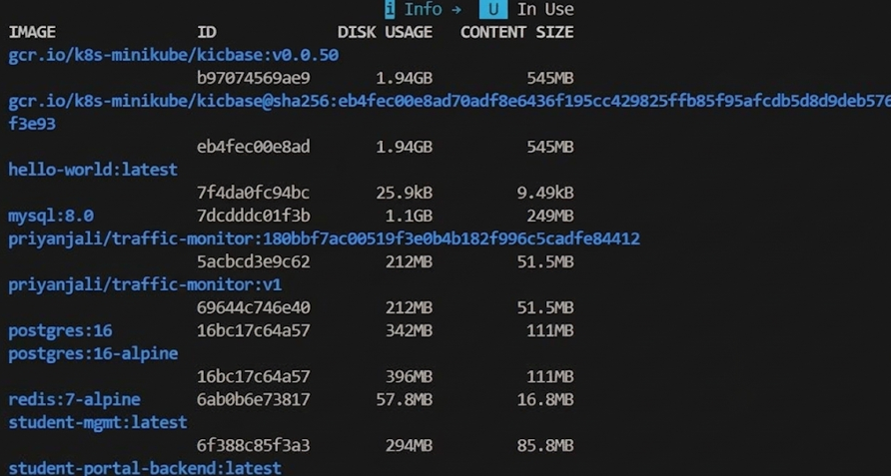

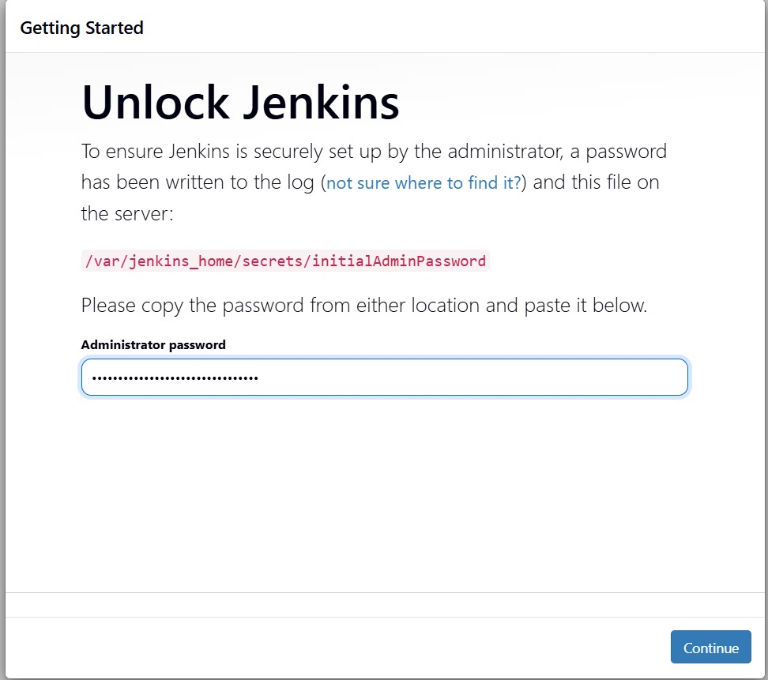
Jenkins displays its initial “Unlock Jenkins” screen. The setup was completed using the administrator password obtained from /var/jenkins_home/secrets/initialAdminPassword.
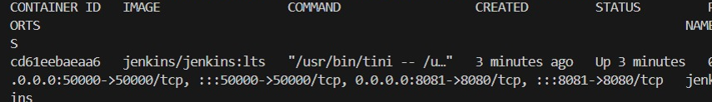
Running docker exec jenkins docker ps confirms that the Jenkins LTS controller, container cd61eebaeaa6, is active with host ports 8081→8080 and 50000→50000 and has access to the Docker daemon.
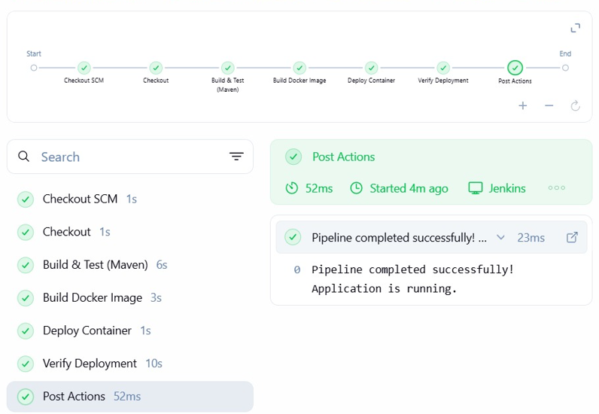
The Jenkins stage view for build #6 shows successful completion of all seven stages in 26 seconds. The final post-action message confirms that the pipeline completed successfully and the application is running.
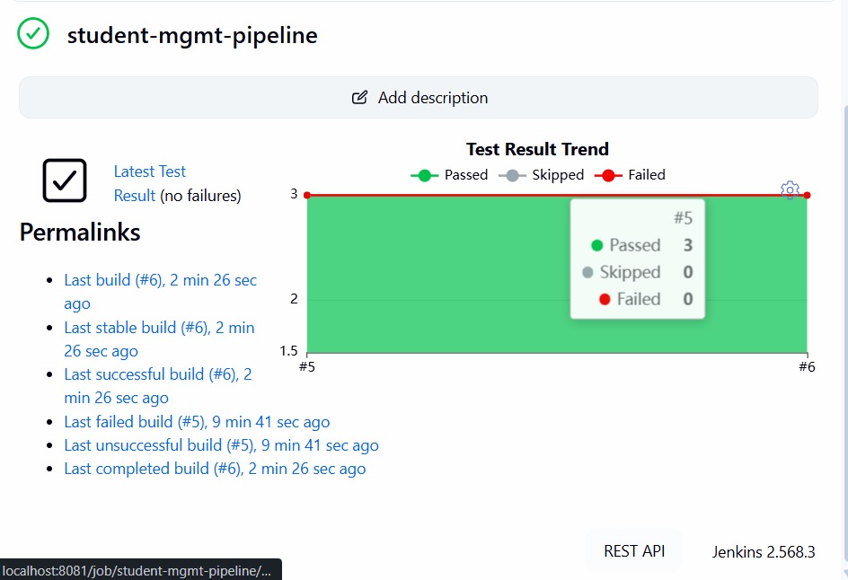
The Jenkins job dashboard records the test trend for build #6: three tests passed, with none skipped or failed. The build is identified as the latest stable and successful build.
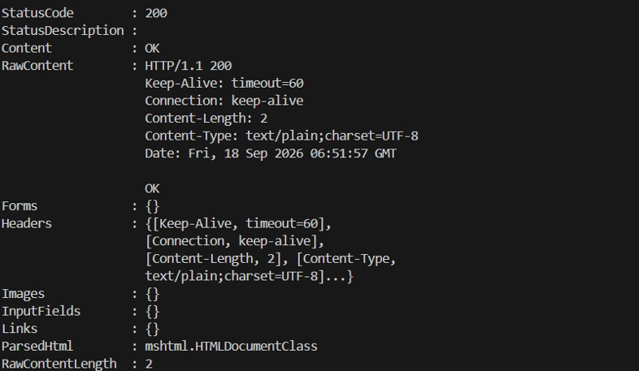
Host-side testing of http://localhost:8080/students/health returns HTTP 200 with the response OK, demonstrating that the deployed application can be accessed from the host.

6. RESULTS AND OBSERVATIONS
- The recorded pipeline completed the full process in about 26 seconds, starting from checkout and ending with deployment verification.
- The successful build reports three passed unit tests. Jenkins stores these results and displays them in the test trend, which makes later failures easier to identify.
- In the recorded runs, build #5 failed and the following build, #6, succeeded after the problem was fixed. This shows that the pipeline status reflects the actual result of the stages.
- Keeping Jenkins inside a container means the main Jenkins environment does not have to be installed directly on the host. The Docker socket provides the required access to the host Docker daemon and makes the setup easier to reproduce.
- Separating the host ports of Jenkins and the application prevented both services from trying to use the same port.
- Before starting a new application container, the deployment stage removes the previous container if it exists. This allows the same pipeline to be run repeatedly without leaving an old container behind.

7. CHALLENGES ENCOUNTERED AND RESOLUTIONS
Challenge | Resolution
Jenkins could not bind to port 8080, which was also needed by the application. | Jenkins was exposed on host port 8081 while retaining port 8080 inside the container.
The Jenkins container initially could not access the Docker CLI/daemon. | The host Docker socket (/var/run/docker.sock) was mounted into Jenkins so pipeline commands could use the host daemon.
The Verify stage sometimes ran before the Spring application had completed startup. | A short delay was added before the health check to allow the application to become ready.
A repeated pipeline run failed when a container with the same name already existed. | A conditional docker rm -f ... || true step was added before starting the new container.

8. CONCLUSION
The experiment produced a working CI/CD pipeline for the Java web application. Git manages the source and provides version history, Maven handles compilation and testing, Docker packages the application, and Jenkins connects these activities into one automated workflow from checkout to deployment verification.
The recorded execution takes roughly half a minute and gives a separate status for each stage. A failed stage prevents the run from being treated as successful. The experiment therefore demonstrates practical DevOps ideas such as automation, repeatable builds, and quick feedback.
Further improvements could include publishing images to Docker Hub with build-specific tags, using a GitHub webhook to trigger Jenkins automatically, adding code-quality or coverage checks, and moving the deployment from a single Docker container to Kubernetes.

